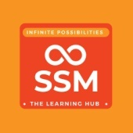 **SSM Institute of Engineering and Technology**

**LIBRARY**

**User Awareness Program on National Digital Library of India - 8-11-2022**

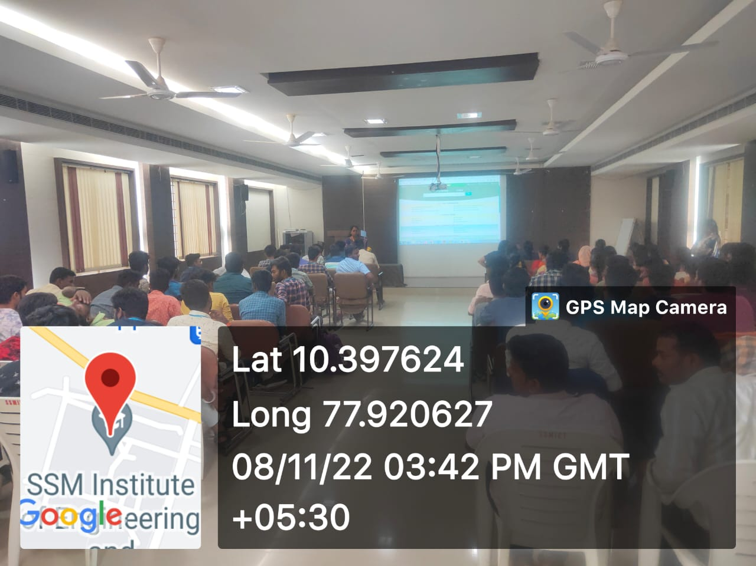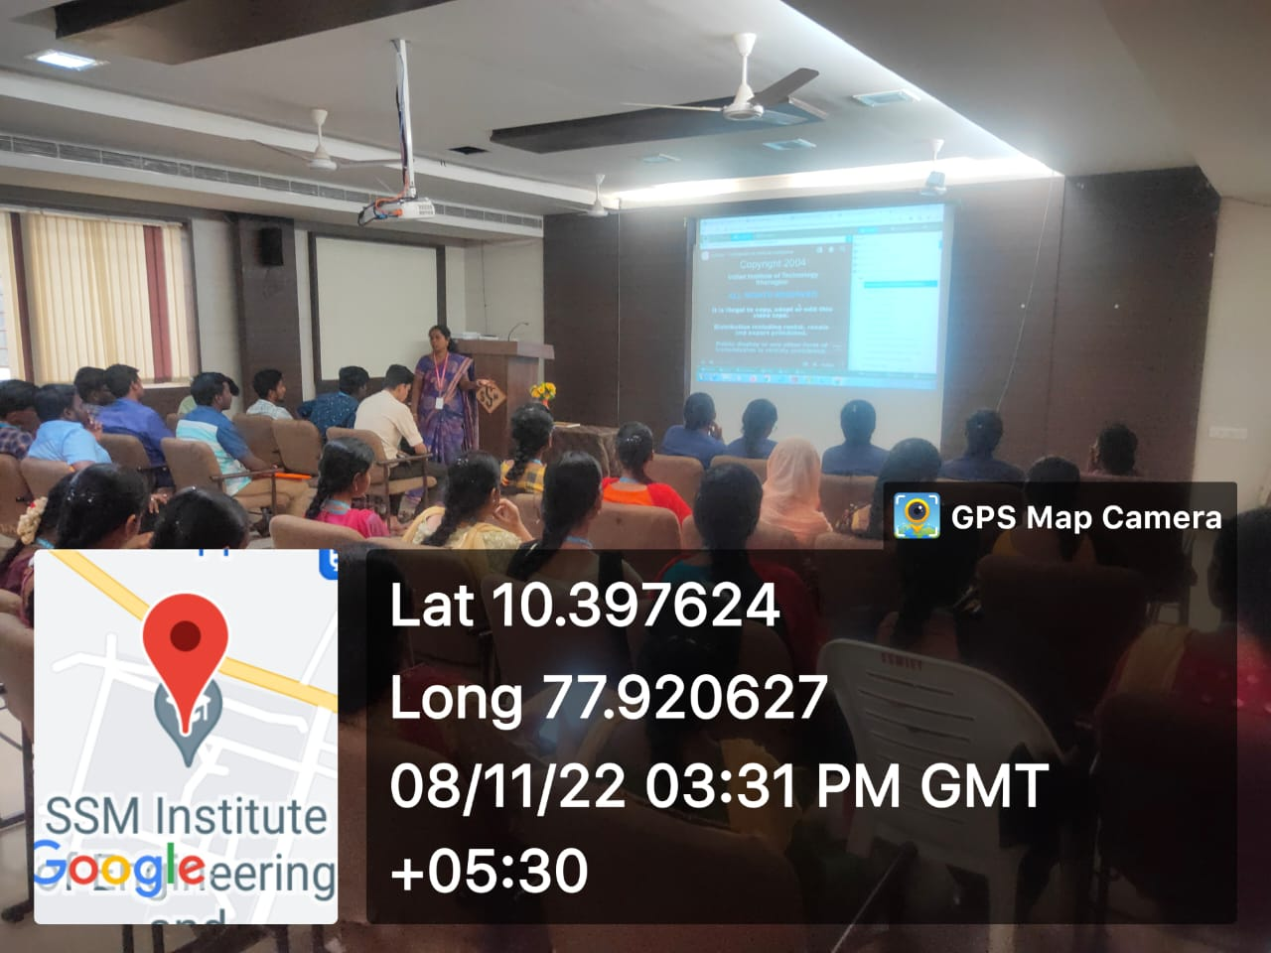SSMIET – NDL Club conducted the User awareness program on National Digital Library of India on 8th November 2022. The aim of this programme is to make the students more familiar with the NDL resources and NDL Club activities etc. The programme was started with a PPT presentation by the Librarian of the college Dr. K.Sudha. NDL is an integrated environment where learners can find out the right resource with least effort and in minimum time. This is a digital repository containing textbooks, articles, videos, audio books, lectures, fiction and all the other kinds of learning media. The NDLI provides free of cost access to many books in the Indian languages and English. Overall the event was an informative and interesting one. Students are eagerly involved and register their opinions about NDL in front of judge.

